RECIPES TO PREVENT HYPERTENSION

RECIPE 1: SOY NOODLES WITH VEGETABLES

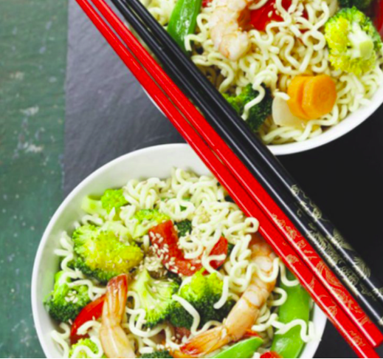
INGREDIENTS FOR 3 PEOPLE:

- A Hundred Grams Of Soy Noodle
- A Couple Of Tablespoons Of Extra Virgin Olive Oil
- 3 Tablespoons Soy Sauce
- A Courgette, Medium
- 14 Tsp. Red Pepper
- 14 Teaspoons Of Yellow Pepper
- A Caraway
- 1 Onion (Spring)
- A Third Of a Pound Of Coral Green Beans
- A Sprinkling Of Bean Sprouts
- A Glass Of Vegetable Broth (12 Oz.)

INSTRUCTIONS

- Fill a pot halfway with water and place it on the stove to bring to a boil.
- While the water begins to boil, place the vegetables on the cutting board and begin cutting them. To begin, cut the carrot lengthwise into 1 mm thick slices, set them on the cutting board, and chop them crosswise.
- Cut the peppers into strips now.
- Using the same cutting technique as the carrot, continue with the zucchini.
- The same method will be used to cut corallo beans.
- Last but not least, chop the spring onion.
- The water will have boiled by this time, so switch off the stove. Add the soy noodles and soak for four minutes (carefully follow the instructions on the spaghetti bag: there are many on the market with varying cooking techniques and periods), then drain and set in a basin with water. cold. Allow them to soak until they're ready to use.
- Heat the Wok over high heat and add 2 teaspoons of oil, then add the vegetables in this order: spring onion first, followed by carrots practically simultaneously.
- After 2 minutes, add the green beans, peppers, and courgette, finishing with the courgette.

Toss your vegetables and cook for 5 minutes. After that, pour in the broth.

Combine all of the ingredients once more. Drain the pasta and add it to the Wok, along with three teaspoons of soy sauce.

Add a handful of bean sprouts last. Make the whole thing jump by moving it around.

Nutritional Values
NUTRIENTS | PER SERVING
Carbohydrates | 30%
vegetable proteins | 45%
Dietary fiber | 6%
Soybeans Protein | 36%
Polyunsaturated fat content | 20%
Calcium | 15%
Motassium magnesium | 12%
Iron and Phosphorus | 5%
Vitamins A, B2, D, and E | 55%

RECIPE 2: ARTICHOKES WITH TOFU, WITH GARLIC AND PARSLEY

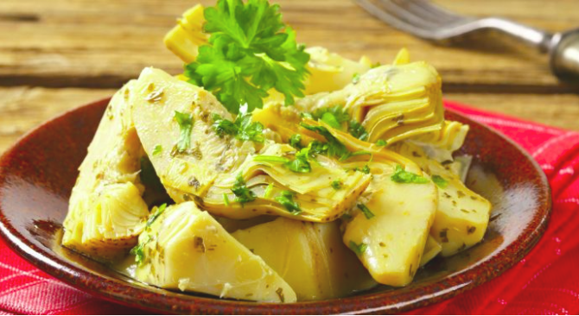

INGREDIENTS FOR 4 PEOPLE:

- 4 Artichokes,
- 3 Tablespoons Extra Virgin Olive Oil,
- 4 Teaspoons Breadcrumbs, And
- 2 Garlic Cloves
- Season With Salt To Taste
- To Flavor Parsley
- Taste The Tofu

INSTRUCTIONS

- Remove the toughest leaves from the artichokes, wash them, and cut them in half. Remove the internal hair, thinly slice it, and season it with salt, pepper, lemon juice, and oil in a bowl.
- Remove the tofu from the package and cut it into cubes. Sauté the garlic in the oil until golden, then add the tofu, a pinch of salt, and a sprinkle of breadcrumbs.
- Continue to brown the tofu for another 2-3 minutes until it turns crisp, then remove from the fire. Remove the garlic cloves from the skillet and combine the tofu with the artichokes in the mixing bowl.
- Season with salt and pepper and a handful of minced parsley.

Nutritional Values

NUTRIENTS | PER SERVING
Protein | 8.1 g per 100 g
Caloric intake | 76 kcal
Protein | 19 g
Carbohydrates | 23 g
Fat | 16 g
Fiber | 7 g
BE | 1.6

RECIPE3: EGGPLANT CASSEROLE WITH MOZZARELLA

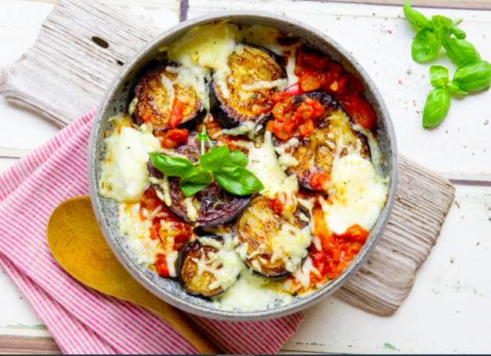

INGREDIENTS:

- 750 g Eggplant
- 1 Onion
- 1 Toe Garlic
- 3 Tbsp Olive Oil
- 400 g Tomatoes (Canned)
- 200 g Mozzarella
- 20 g Freshly Grated Parmesan
- Salt
- Freshly Ground Pepper
- Dried Oregano
- Fresh Basil

INSTRUCTION

- Preheat the oven to 220°F (top/bottom heat) or 200°F (circulating air). Wash, dry, and clean the aubergines before slicing them into finger-thick slices.
- Place on a baking sheet coated with parchment paper and grill for 5-7 minutes on both sides in the oven. The eggplants are done when they turn color. Do not turn the stove off.
- Peel the onion and garlic, cut the onion into rings, and finely dice the garlic in the meantime (omit onions and garlic if you have gastritis).
- Wash and dry the basil leaves before plucking and cutting them into tiny strips. In a skillet, gently heat the oil and sauté the onion rings and garlic.
- Add the peeled tomatoes, season with salt, pepper, oregano, and basil, and cook, uncovered, for 8-10 minutes over low heat.
- Cut the mozzarella into thin slices (use reduced-fat mozzarella if you suffer reflux or heartburn). Brush a casserole dish thinly with oil, then top with 2 tablespoons tomato sauce and aubergine slices.
- On top, layer 2 tablespoons grated parmesan, 2-3 tablespoons tomato sauce, and mozzarella slices. Carry on in this manner until all of the food has been consumed. Mozzarella and parmesan make up the top layer.
- Bake for 15-20 minutes in a preheated oven (middle).

NUTRITIONAL VALUES (PER SERVING):

NUTRIENTS | PER SERVING
Carbohydrates | 8 g
Fiber | 4 g`
Fat | 20 g
Protein | 16 g
Caloric intake | 290 kcal

RECIPE 4: BERRY GRANOLA
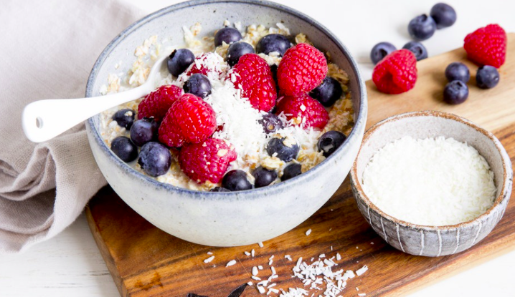

INGREDIENTS (FOR 1 PERSON):

- 100 g Soft Fruits
- 3 Tablespoons Oats
- 150 Ml Almond Or Oat Drink
- 1 Tablespoon Almonds, Flax Seeds, Or Coconut Flakes

INSTRUCTION

- Pour almond or oat milk over the oat flakes and fresh or thawed berries (e.g. strawberries, raspberries, blueberries) in a bowl.
- Then refine the muesli with almonds, linseed, and coconut flakes to taste.

NUTRITIONAL VALUES:

NUTRIENTS | PER SERVING
Fat | 13 g
Carbohydrates | 25 g
Protein | 10 g
Fiber | 8 g
Caloric intake | 254 kcal

RECIPE 5:YOGURT WITH BERRIES AND WHEAT BRAN

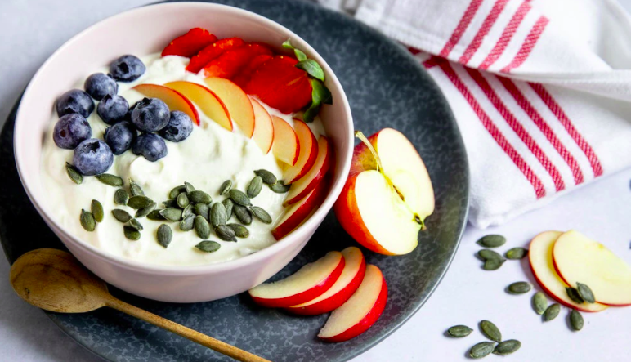

INGREDIENTS:

- 0.5apple Is a Fruit That Is Grown In The United States.
- 1 Handful Of Strawberries (Approximately 1 Pound)
- Alternatively, Other Berries (Fresh Or Frozen)
- 100 g Yogurt (3.5 Percent Fat)
- A Half-Dozen Glowfat Quarks
- 2 Tablespoons Wheat Bran
- 1 Tablespoon Linseed Oil
- 1 Tablespoon Pumpkin Seeds

INSTRUCTION

- The apple should be cored and diced, and the berries should be washed and dried before being cut into small pieces if they are fresh.
- In a mixing bowl, combine the yogurt and the remaining ingredients until smooth.
- Scatter fruit and pumpkin seeds on top.

NUTRITIONAL VALUES (PER SERVING):

NUTRIENTS | PER SERVING
Fat | 19 g
Carbohydrates | 20 g
Protein | 16 g
Fiber | 5 g
BE | 1.6
Caloric intake | 315 kcal

RECIPE 6: BREAD FROM THE TRAY WITH VEGETABLES
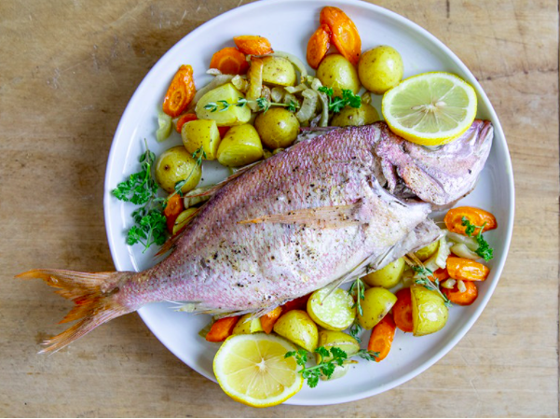

INGREDIENTS:

- 400 g(With Green) Fennel
- 250 g(In a Bunch) Carrots
- 250 g Tiny Waxy (e.g. Triplets) Potatoes
- 1 Tsp Fennel Seeds
- Salt
- Pepper (From The Mill)
- 2 Tbsp Olive Oil
- 1 Ready-To-Cook Bream
- 1 Tbsp Lemon Juice
- 4 Toes Garlic
- 2 Tbsp Butter
- For The Tray: a Little Olive Oil

INSTRUCTION

- Preheat the oven to 220 degrees Fahrenheit on the top and bottom racks (convection 200 degrees). A baking sheet should be greased.
- Clean and wash the fennel, then set aside the fragile greens. Remove the hard stalk from the fennel and cut the halves into 1 cm broad wedges. Carrots should be cleaned, peeled, and halved lengthwise.
- Wash and dry the potatoes before cutting them in half or halves, depending on their size.
- Fennel, carrots, and potatoes should be spread out on the tray. In a mortar, crush the fennel seeds. Drizzle olive oil over the vegetables and season with fennel seeds, salt, and pepper. Cook for 15 minutes on the middle rack of the oven.
- Meanwhile, wash the bream inside and out, pat dry, season with salt and pepper, and acidify with lemon juice if preferred. Garlic cloves should be peeled, sliced into wedges, and poured into the bream.
- Place the fish on top of the vegetables after 10 minutes of cooking and top with flakes of butter.
- Cook the bream and veggies for around 25 minutes on the middle shelf of the oven.
- Remove from the oven and divide among plates, garnishing with chopped fennel leaves.

NUTRITIONAL VALUES (PER SERVING):

NUTRIENTS | PER SERVING
Protein | 39 g
Fat | 22 g
Carbohydrates | 33 g
Fiber | 9 g
BE | 3
Caloric intake | 500 kcal

RECIPE 7: MIXED VEGETABLE SOUP

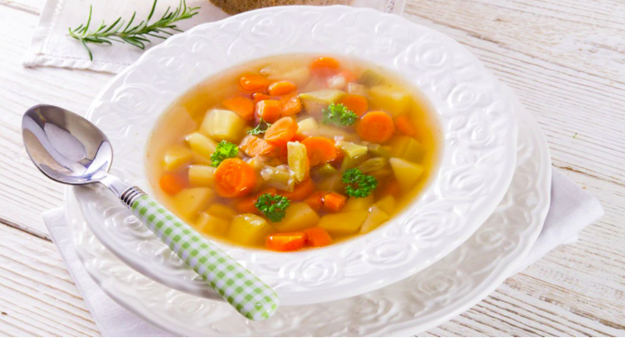

INGREDIENTS FOR 4 PERSONS):

- 1 Carrot
- 1 Leek
- 1 Small Kohlrabi
- 50 g Celeriac
- 12 Tiny White Cabbage
- 2 Garlic Cloves
- 1 Onion
- 500 Ml Vegetable Stock
- 5 Juniper Berries
- 1 Bay Leaf
- 2 Tablespoons Rapeseed Oil
- Pepper
- Nutmeg
- 2 Tablespoons Frozen Peas

INSTRUCTION

- Vegetables should be cleaned and washed. Carrots should be thinly sliced. Finely slice the white and light green sections of the leek. Chop the kohlrabi and celery finely.
- Using a sharp knife, shave the cabbage into tiny strips. The onion and garlic cloves should be peeled and finely chopped.
- In a pot, heat the oil. Cook the onion and garlic cubes in it for 3 minutes before adding the vegetables (excluding the peas).
- Add the juniper berries and bay leaf (packed in a sealed linen bag or a tea infuser) to the pot with the vegetable stock. Bring the soup to a boil, then reduce to a low heat and cook for 5 minutes. Vegetables should still have a bit of bite to them.
- Remove the soup from the heat, toss in the peas, and set aside in a covered pot for another 2 minutes.
- Serve with a pinch of salt, pepper, and nutmeg.

NUTRITIONAL VALUES (PER SERVING):

NUTRIENTS | PER SERVING
Protein | 6 g
Fat | 4 g
Carbohydrates | 16 g
Fiber | 12 g
Caloric intake | 150 kcal

RECIPE 8: COUSCOUS BOWL WITH MINT YOGURT

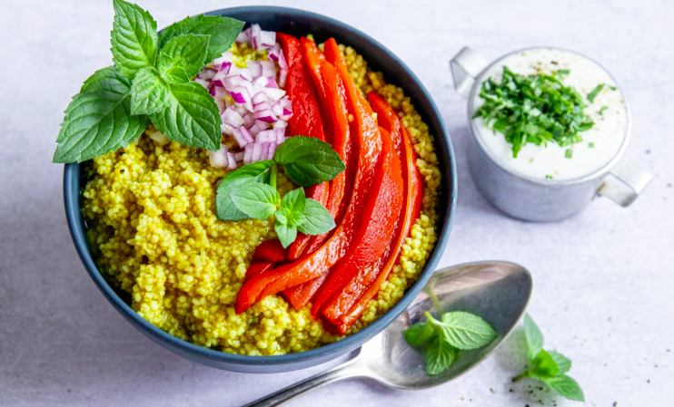

INGREDIENTS:

- 200 g Couscous 350 Ml Vegetable Broth
- 0.5 Teaspoon Cinnamon
- 1 Tsp Cumin Powder
- 1 Tsp Turmeric Powder
- Saline
- Black Pepper, Freshly Ground
- 4 Tablespoons Olive Oil
- 1 Onion, Red 1 Onion, Red 1 Onion, Red 1 Onion, Red 1 Onion,
- 250 g Roasted Skinned Peppers (From The Jar)
- 500 g Natural Yogurt (3.5 Percent Fat)
- 2.5 Tablespoons Milk
- 2 Mint Stems (Fresh)
- 1 Teaspoon Of Sugar

INSTRUCTION

- In a large mixing bowl, pour the boiling hot broth and whisk in the couscous. Cover and set aside for 10 minutes to soak. Season with spices to taste and drizzle with olive oil.
- Divide the mixture into two bowls.
- Peel the onion and finely slice it. Drain and chop the peppers into thin slices. Pour the sauce over the couscous.
- Blend the yogurt and milk together until smooth. Mint should be washed, dried, and finely chopped.
- Sprinkle with the mint and season with salt, pepper, and sugar.
- Serve alongside couscous.

NUTRITIONAL VALUES (PER SERVING):

NUTRIENTS | PER SERVING
Carbohydrates | 88 g
Fat | 35 g
Protein | 25 g
Fiber | 10 g
BE | 7
Caloric intake | 772 kcal

RECIPE 9: FISH PAN WITH SPRING VEGETABLES

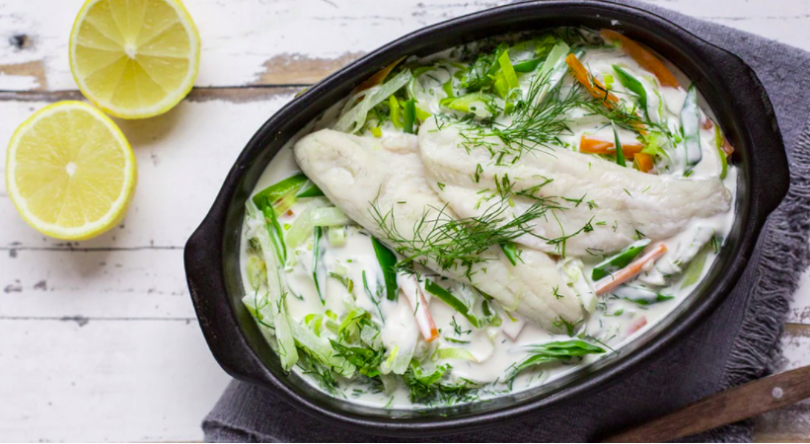

INGREDIENTS (FOR 1 PERSON):

- A Half Onion
- 1 Leek (Half a Stick)
- 1 Cauliflower
- Kohlrabi (Half a Kohlrabi)
- A Hundred Grams Of Sugar Snap Peas
- 1 Tablespoon Rapeseed Oil
- Saline
- Peppercorns
- 150 Milliliters Vegetable Stock
- 2 Fish Fillets (About 80 g Each)
- 1 Tablespoon Lemon Juice
- 2 Tablespoons Sour Cream
- 50 g Quark (Low-Fat)
- 50 g Yogurt (Natural)
- 2 To 3 Dill Stalks
- Cayenne Pepper Is a Spicy Pepper That Can Be Used In a Variety Of Dishes

INSTRUCTION

- Cut the onion into fine pieces after peeling it. Cut the leek into rings after cleaning and washing it. Cut the carrot and kohlrabi into tiny strips after peeling them.
- Sugar snap peas should be cleaned and washed.
- In a pan, heat the oil. It's where you'll cook the onion and leek.
- Season with salt and pepper after adding the carrot and kohlrabi. Pour the broth in.
- Wash and wipe dry the fish fillets, then drizzle with lemon juice and season with salt and pepper.
- Place the fillets on top of the vegetables and simmer for 10-15 minutes, covered.
- Add the snow peas 5 minutes before the end of the cooking time and cook with them.
- Meanwhile, combine the sour cream, low-fat quark, and yogurt.
- Wash the dill and pat it dry before removing the tips and coarsely chopping it. Season with the remaining lemon juice, salt, pepper, and cayenne pepper and stir the dill into the sour cream mixture.
- With the dill cream, serve the fish and vegetables.

Nutritional Values (Per Serving):

NUTRIENTS | PER SERVING
Protein | 44.3 g
Fat | 23.6 g
Carbohydrates | 20.5 g
Fiber | 7.3 g
Caloric intake | 479 kcal

RECIPE 10: SPRING VEGETABLES WITH TOFU FROM THE WOK

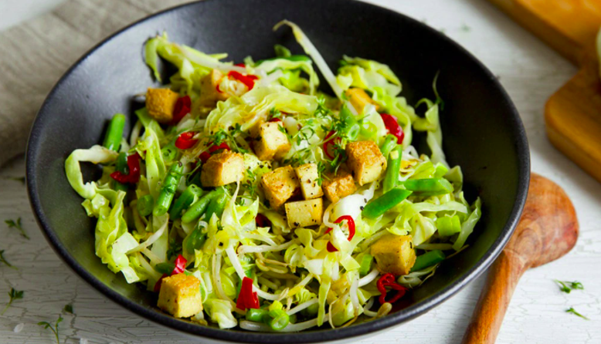

INGREDIENTS FOR 4 PERSONS:

- 500 g Asparagus (Green)
- 2 Yellow Or Red Peppers, As An Option
- 1 Bunch Of Spring Onions 1 Bunch Of Spring Onions 1 Bunch Of Spring Onions 1 Bunch Of Spring Onions 1
- 350 g Cabbage (Pointed)
- 1 Serving Of Watercress
- 1 Packet Mixed Sprouts (100 g)
- 25 g Ginger, Fresh
- A Couple Of Garlic Cloves
- 1 Chile Pepper, Dried
- 3–4 Tablespoons Soy Sauce
- 3 Tablespoons Lime Juice
- 4 Tablespoons Of Oil
- A Third Of a Pound Of Tofu
- Wholemeal Spelled Flour To Turn

INSTRUCTION

- Wash the asparagus, remove the woody ends, and cut the stalks into 2 cm broad oblique sections. Alternatively, wash the peppers, core them, and chop them into appropriate pieces.
- Spring onions should be cleaned and washed before being sliced into bits. Remove the stalk from the pointed cabbage after cleaning and washing it. Using a sharp knife, shave the cabbage into tiny strips. The watercress should be cleaned, washed, and dried.
- Cut into little bite-size pieces. Ginger and garlic should be peeled and coarsely chopped. Dried chili should be crumbled. In a mixing bowl, combine everything except the soy sauce and lime juice.
- Add the sesame oil and mix well.
- In a wok or a deep pan, heat 2 tablespoons of oil. Toss the tofu in a little wholemeal flour and cut it into bite-size pieces.
- Fry till golden brown in heated oil. Season with salt and pepper to taste. Remove the pan from the heat and drain on kitchen paper. Remove the oil and drain it.
- In the wok, heat the remaining oil.
- Cook the asparagus in it for 1-2 minutes, stirring constantly. Fry the spring onions and cabbage, as well as the remaining veggies, for a minute.
- Fold in the tofu pieces after mixing in the marinade. Season with salt and pepper to taste.

Variation:
Instead of asparagus, the tofu pan is also delicious when seasoned with mild paprika.

NUTRITIONAL VALUES (PER SERVING):

NUTRIENTS | PER SERVING
Carbohydrates | 20 g
Fat | 24 g
Protein | 22 g
Fiber | 8 g
BE | 1.7
Caloric intake | 383 kcal

EATING FOR A HEALTHY METABOLISM –
RECIPES TO PREVENT DIABETES
RECIPE 1: RICE WITH GREEN PEAS AND HERBS FROM THE GARDEN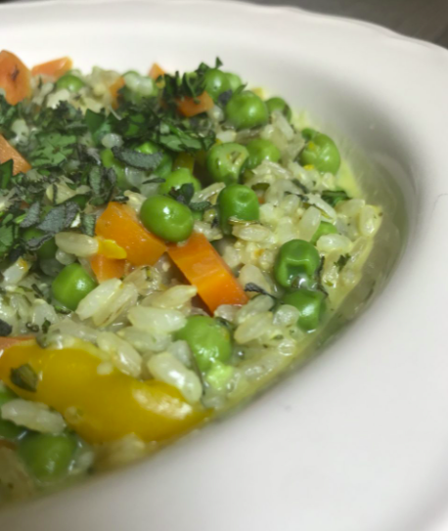
INGREDIENTS
- 300 g Rice (Semi-Wholemeal)
- 1 Fresh Spring Onion 300 g Peas
- Extra Virgin Olive Oil, 2 Soup Spoons
- 3/4 c. Lactose-Free Skimmed Milk
- Parmigiano Reggiano Cheese, 4 Soup Spoons
- 300gr Vegetable Mix (To Taste)
- Spinach, Zucchini, Carrots, And Other Vegetables
- a Bouquet Of Fresh Garden Scents
- Rosemary, Basil, Thyme, And Sage.

PREPARATION
- Cook For 30 Minutes In a Saucepan With Enough Water And Vegetables To Make a Vegetable Broth, Then Begin Preparing The Other Ingredients For The Dish.
- Finely Chop The Fresh Onion And Herbs. Finely Chop The Vegetables. Combine The Onion And The Oil In a Saucepan.
- Pour In The Water And Cook For 3 Minutes. Incorporate The Vegetables
- Add The Peas And Cook For 5 Minutes With a Ladle Of Vegetable Broth. Combine The Rice And Vegetables
- Add The Broth a Little At a Time Until It's Cooked, About 15 Minutes. Add The Milk And Parmesan Cheese. Serve

NUTRITIONAL VALUE
Apart from their fairly sweet, starchy and delicious taste green pea is a good source of nutrients, vitamins and minerals.
NUTRIENTS | Amount Per 100 g | Daily Value Percentage
Vitamin C | 58 mg
Vitamin B1 | 0.386 mg
Copper | 0.255 mg
Iron | 2.13 mg
Manganese | 0.594 mg
Vitamin B9 | 94 µg
Amino acids
Tryptophan | 0.054 g
Threonine | 0.294 g
Isoleucine | 0.283 g
Leucine | 0.468 g
Lysine | 0.46 g

RECIPE 2: PEASANT PUMPKIN SOUP WITH OLIVES AND CAPERS
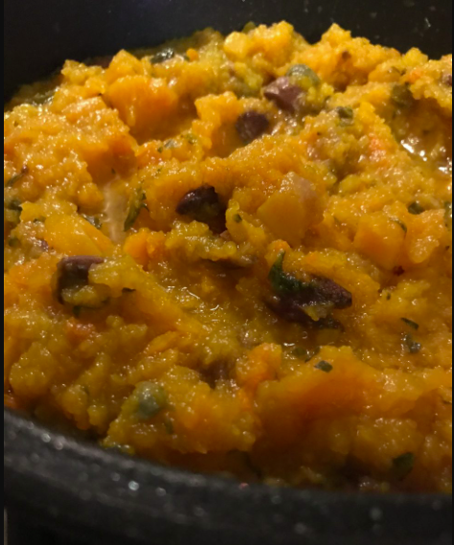
INGREDIENTS
- 400 g Pulp From Pumpkin
- Leaves Of Basil
- A Few Parsley Leaves
- A Pinch Of Salt (Coarse)
- A Drink Of Water
- A Pinch Of Chilli 2 Soup Spoons Extra Virgin Olive Oil
- 1 Onion (Vatolla) Red
- 4 Soup Spoons Taggiasca Olives, Pitted

PREPARATION
- Rinse The Capers And Soak Them In a Cup With Half a Glass Of White Wine To Remove The Salt.
- Wash And Cut The Pumpkin Into Cubes
- Finely Dice The Onion
- In a High-Sided Pot, Combine The Oil, Onion, a Splash Of Water, And Red Pepper; Cook For 3 Minutes.
- Toss The Onion Stew With The Pumpkin, Capers, Soaking Wine, And Olives.
- Stir In The Fresh Herbs And Half a Glass Of Water.
- Cover The Pot And Cook The Pumpkin For About 30 Minutes.
- It Will Not Be Necessary To Blend The Pumpkin Once It Has Been Cooked Because It Will Have Undone Sufficiently And Retained The Proper Amount Of Liquid.
- Serve.

NUTRITIONAL VALUE

NUTRIENTS | Amount Per 100 g | Daily Value Percentage
Fat | 0.2 grams
Protein | 2 grams
Carbs | 12 grams
Fiber | 3 grams
Vitamin A |  | 245%
Vitamin C |  | 19%
Potassium: |  | 16%
Copper |  | 11%
Manganese |  | 11%
Vitamin B2 |  | 11%
Vitamin E |  | 10%
Iron |  | 8%
Calories | 49

RECIPE 3: CALAMARATA OF FREGOLA
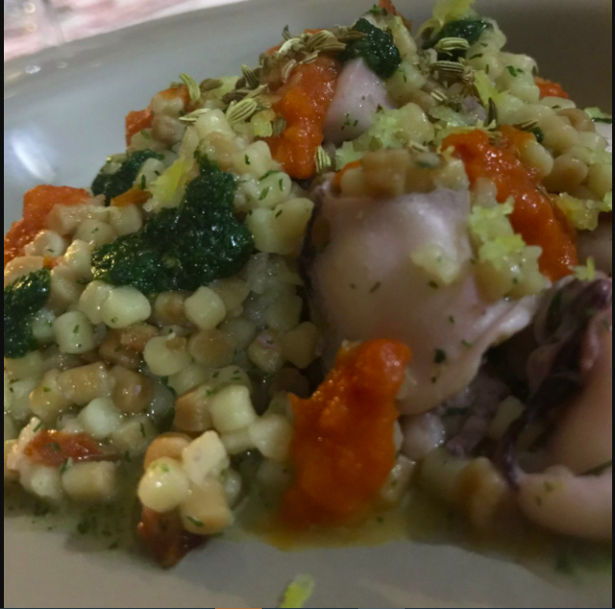
INGREDIENTS
- Squid (Nine)
- 30 Milliliters Extra Virgin Olive Oil
- 4 Tomatoes (Sun-Dried)
- 2 Capers (Salted) Soup Spoons
- Fregola 320 Gr (Pasta)
- Fennel Seeds, 1 Tablespoon
- Fennel, 25 g
- Tomatoes, 8
- A Lemon Peel, Shredded
- 1 Cube Of Ice
PREPARATION
- Soak The Capers And Dried Tomatoes For 10 Minutes After Rinsing Them From The Salt.
- On a Nonstick Pan, Roast The Fennel Seeds. Grate 1⁄2 a Lemon Peel And Leave Away. Fennel Should Be Washed. Mix The Dill With An Ice Cube In a Blender. Pour In The Oil
- Put The Blender On. Place The Fennel Pesto In a Bowl In The Refrigerator Until Ready To Use As a Garnish. Preheat The Oven To 180 Degrees And Wash The Tomatoes In The Meantime.
- Arrange The Tomatoes, Sliced In Half, In a Pan Lined With Parchment Paper.
- Bake The Tomatoes At 180 Degrees For 10 Minutes. Puree Them In a Basin 13: Rinse The Tomatoes And Capers And Chop Them With a Half-Moon
- Make The Breadcrumbs Toasty. In a Pan, Sauté The Squid Sliced Into Rings For 3 Minutes, Then Turn Off The Heat As Soon As They Start To Boil.
- In a Saucepan, Boil The Fregola Until It Is 3/4 Cooked, Then Drain It Roughly And Pour The Remaining Water Into The Pan With The Squid, Place On a High Temperature, And Complete Cooking.
- Stir In The Smashed Tomatoes And Capers, As Well As a Few Teaspoons Of Fennel Pesto. Finally, Combine Everything And Serve.
- Finish The Dish With a Few Drops Of Fennel Pesto, a Few Drops Of Blended Tomato, And a Few Drops Of Basil Pesto.

NUTRITIONAL VALUE
NUTRIENTS | Amount Per 100 g | Daily Value Percentage
Calories | 339.29 Kcal (1421 kJ)
Calories from fat | 16.07 Kcal
Total Fat | 1.79g | 3%
Sodium | 17.86mg | 1%
Total Carbs | 73.21g | 24%
Sugars | 5.36g | 21%
Dietary Fiber | 3.57g | 14%
Protein | 10.71g | 21%
Iron | 0.5mg | 3%

RECIPE 4: WHOLEMEAL SPAGHETTI WITH ONION, ANCHOVY AND CINNAMON

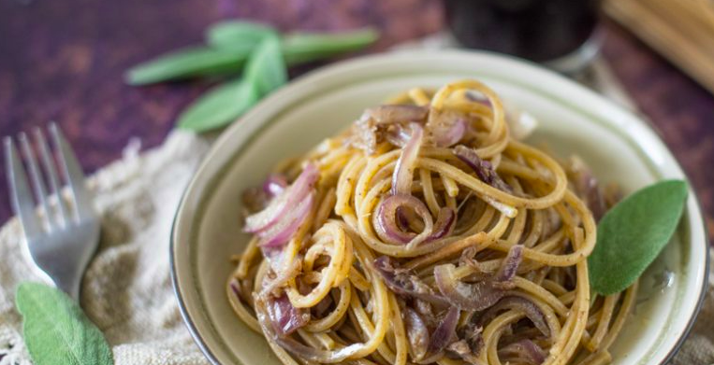

INGREDIENTS
- 320 grams pasta (wholemeal square spaghetti)
- 4 red Tropea onions
- Extra virgin olive oil, 6 tbsp
- 1 sprig of sage
- 7 anchovies
- only a pinch of salt
- only a pinch of pepper
- Just a pinch of cinnamon

PREPARATION

- Bring the water to a boil for the pasta, then season with salt and cook the spaghetti. Meanwhile, thinly slice the onions. Heat the oil, then add the onions and sage and simmer, stirring occasionally, over low heat.

- Add the anchovies and gradually melt them in as well. Cook the spaghetti until it is al dente.

- Add the spaghetti, together with a teaspoon of the boiling water and cinnamon, to the now soft and almost caramelized onions. Serve with a pinch of salt and pepper.

NUTRITIONAL VALUE

NUTRIENTS | PER SERVING
Fat | 9g
Cholesterol | 95mg
Saturated Fat | 2g
Carbohydrates | 50g
Insoluble Fiber | 9g
Protein | 39g
Sodium | 418mg
Calories | 437

RECIPE 5: REDFISH WITH PEANUT SAUCE AND LIGHTNING KIMCHI

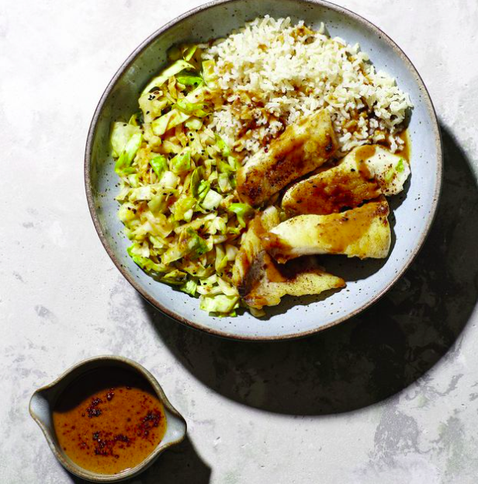

INGREDIENTS

- 2 Teaspoons Of Rapeseed Oil
- Brown Rice (100 g)
- Saline
- Cabbage (400 g)
- 1 Garlic Clove 1 Garlic Clove 1 Garlic Clove 1 Garlic Clove 1 Garlic Clove 1 Garlic Clove 1
- 1 Ginger Slice (Approx. 1 Cm Long)
- 2 Tablespoons Lemon Juice
- Chipotle Flakes
- 1 Teaspoon Sesame Seeds, Black (To Taste)
- Peanut Butter (40 g)
- 1 Tablespoon Soy Sauce (Alternatively Salt)
- Pair Of Redfish Fillets (100 g Each)

PREPARATION

- In a small saucepan, heat 1 teaspoon of oil and sauté the rice for around 1 minute. Pour in 200 mL of water, bring to a boil, season with salt, cover, and simmer for about 25 minutes over low heat. Then turn off the heat and cover with rice, allowing it to rest for about 5 minutes.
- Meanwhile, wash the cabbage for the kimchi, remove the stalk, slice lengthwise into 3 cm wide slices, and crosswise into fine strips. Peel and finely chop the garlic and ginger.
- In a mixing bowl, combine the cabbage strips, garlic, ginger, 1 teaspoon salt, and 12 tablespoons lemon juice and knead vigorously with your hands for 5-10 minutes, or until the cabbage is lovely and crumbly and has lost its crunch. Season with chili flakes and sesame seeds, if desired, and set aside until ready to serve.
- In a small saucepan, heat the peanut butter and 100 mL water for the sauce. Season with soy sauce and chili flakes, if desired, and keep warm.
- Dry the redfish with kitchen paper and season with salt and the remaining lemon juice (12 tbsp).
- In a nonstick pan, heat the remaining oil (1 teaspoon) and fry the fillet pieces for 1-2 minutes on each side over medium to high heat, then turn off the heat and let the fish simmer for another 2 minutes.
- Fluff the rice with a fork and serve with the fish, kimchi, and sauce on two dishes.

NUTRITIONAL VALUE:

NUTRIENTS | PER SERVING
Fat | 0g
Sodium | 290mg
Fiber | 1g
Sugars | 2g
Protein | 1g
Vitamin C | 18mg
Calories | 20
Carbohydrates | 4g

RECIPE 6: ZUCCHINI SPAGHETTI WITH LENTIL BOLOGNESE

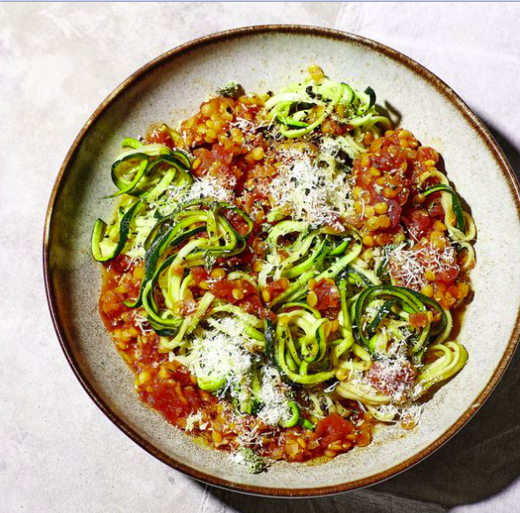

INGREDIENTS

- 1 Shallot (Approx. 80 g)
- Single Garlic Clove
- 2 Tbsp Extra Virgin Olive Oil
- Tomato Paste, 2 Tblsp
- Red Lenses, 100 g
- 1 Can Tomato Chunks (400 g)
- Zucchini (400 g)
- 60 g Parmesan Cheese
- Salt
- Pepper
- 1 Teaspoon Oregano, Dry

PREPARATION

- Peel and finely dice the onion and garlic. In a saucepan, heat 1 tablespoon olive oil and sauté the onion and garlic cubes until transparent.
- Roast for 1 minute after adding the tomato paste. Simmer the sauce for about 15 minutes over medium heat with the lentils, chunky tomatoes, and 150 ml water.
- Meanwhile, rinse and wash the zucchini before spiraling or cutting it into "spaghetti" with a sharp knife. Parmesan cheese should be grated.
- When the lentils are done, add half of the Parmesan, season with salt, pepper, and oregano, and keep warm until ready to serve.
- In a nonstick skillet, heat the remaining oil (1 tbsp) and sauté the zucchini spaghetti for 3-4 minutes over medium heat, lightly salting, and then dividing over two deep dishes. Top with the lentil Bolognese and the leftover Parmesan cheese (30 g).

NUTRITIONAL VALUE:

NUTRIENTS | PER SERVING | Daily Value %
Total Fat | 7g | 9%
Saturated Fat | 1g | 5%
Cholesterol | 2mg | 1%
Sodium | 373mg | 16%
Total Carbohydrate | 51g | 19%
Dietary Fiber | 14g | 50%
Total Sugars | 13g
Includes 0g Added Sugars |  | 0%
Protein | 15g
Vitamin D 0mcg |  | 0%
Calcium | 89mg | 7%
Iron | 5mg | 28%
Potassium | 1233mg | 26%
Calories |  | 307

RECIPE 7: OAT AND FENNEL STEW

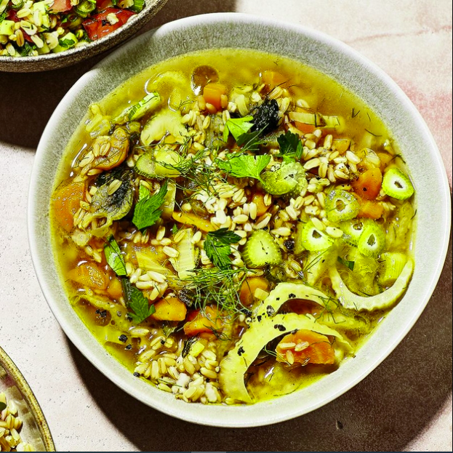

INGREDIENTS

- 1 Scallions
- Single Carrot (Approx. 80g)
- Fennel (100 g)
- Half Teaspoon Of Fennel Seeds (Alternatively Dried Marjoram)
- 70 g Oat Grains, Dry
- Vegetable Broth (300 Ml)
- 2 Parsley Stems
- Salt
- Pepper

PREPARATION

- The shallot should be peeled and finely diced. Clean, peel, and half the carrot lengthwise; wash, halve, and remove the stalk from the fennel.
- Both should be cut into fine strips. In a mortar, pound the fennel seeds to a fine powder.
- Over medium heat, roast the oats for about 2 minutes. Add the prepared ingredients, bring to a boil, and simmer for about 30 minutes, covered, over medium heat.
- Season with salt and pepper to taste.
- Wash the parsley leaves, shake them dry, and finely cut them before sprinkling them over the stew.

NUTRITIONAL VALUE:

Oatmeal is high in several vitamins and minerals, including these:
- Manganese
- Molybdenum
- Phosphorus
- Copper
- Biotin
- Vitamin B1 (Thiamine)

NUTRIENTS | PER SERVING | Daily Value %
Protein | 1 g | 2 %
Fat | 0.2 g
Carbohydrates | 6 g
Fiber | 2.7 g | 11%
Natural Sugars | 3 g
Calcium | 43 mg | 4%
Iron | 0.64 mg | 3%
Magnesium | 15 mg | 3%
Potassium | 360 mg | 7%
Vitamin A | 838 international units (IU) | 17%
Vitamin C | 10.4 mg | 17%
Calories | 27

RECIPE 8: KOHLRABI STEW WITH MEATBALLS

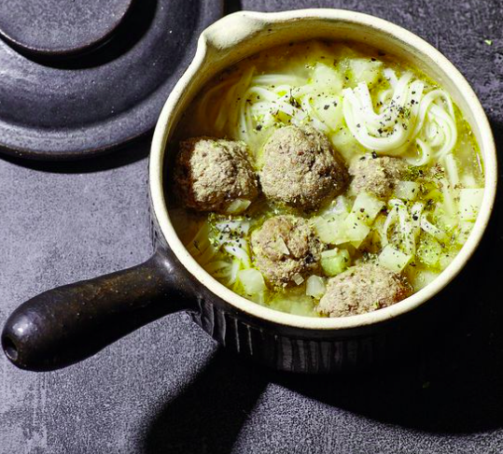

INGREDIENTS
- Rice Noodles (80 g) Salt
- 2 Kohlrabi, Tiny (Approx. 400 g Cleaned)
- 1 Shallot (Approx. 80 g)
- 2 Tbsp Extra Virgin Olive Oil
- Vegetable Broth (700 Ml)
- 200 g Tartare De Boeuf
- Single Egg (m)
- 1 Teaspoon Mustard, Medium-Hot
- 10 g Breadcrumbs (Whole Grain)
- Pepper
- 1 Tsp Marjoram (Dried)

PREPARATION

- Cook the rice noodles according to package directions in plenty of boiling salted water, strain, and rinse in cold water before draining.
- Clean and peel the kohlrabi and chop into 1 cm cubes while the noodles are cooking. The onion should be peeled and diced. In a saucepan, heat the oil and sauté the kohlrabi and onion.
- Pour in the vegetable stock, bring to a boil, then reduce to a low heat and allow the stew simmer for 10 minutes.
- Meanwhile, make a smooth dough with the tartare, egg, mustard, breadcrumbs, and a pinch of salt and pepper in a mixing bowl.
- With moistened hands, form the mixture into walnut-sized balls.
- Stir in the noodles with a fork into the stew. Then add the meatballs to the stew, cover, and simmer for about 5 minutes over medium heat.
- Season the stew with salt, pepper, and marjoram before serving it on two deep dishes.

NUTRITIONAL VALUE:

Kohlrabi is rich in potassium, which can help reduce the risk of serious health conditions like cancer, diabetes, stroke, and heart disease.
It’s also an excellent source of:
- Magnesium
- Phosphorous
- Calcium
- Iron
- Vitamin C
- Folate

NUTRIENTS | PER SERVING
Protein | 2 g
Fat | 0 g
Carbohydrates | 8 g
Fiber | 5 g
Sugar | 4 g
Calories | 36

RECIPE 9: CHICKEN AND VEGETABLE CASSEROLE
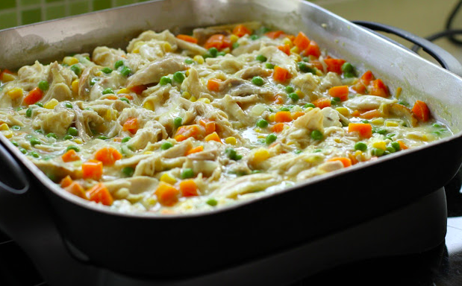

INGREDIENTS
- 2 Tbsp Extra Virgin Olive Oil
- 1 Tablespoon Of Honey
- 2 Tablespoons Soy Sauce
- 1 Tablespoon Of Chili Sauce
- Tablespoon Of Cranberries (From The Glass)
- Tomato Paste, 1 Tbsp
- Salt
- Pepper
- 400 g Fillet De Poulet
- Single Garlic Clove
- 1 Onion, Big
- 2 Rosemary Branches
- 1 Thyme Branch
- 2 Tomatillos
- 1 Zucchini, Big
- 1 Pepper (Red)
- 1 Pepper, Yellow
- 1 Tablespoon Of Rapeseed Oil
- 25 Ml Broth De Poulet

PREPARATION

- Mix the olive oil, honey, soy and chili sauce, cranberries, tomato paste, salt, and pepper to a marinade. Rinse the chicken breast fillets with cold water, pat dry, cut into bite-sized pieces, then mix with the marinade in a bowl and let steep for 1 hour.
- Preheat the oven to 180 °. Peel garlic and chop finely. Peel the onion, cut it in half and cut it into rings. Rinse 1 sprig of rosemary and thyme with cold water, shake dry, remove the needles or leaves, and chop.
- Wash and clean the tomatoes and zucchinis, remove the stalks, and dice. Quarter, clean, wash and dice the peppers.
- Heat the oil in a small pan, sauté the onion, garlic, thyme, and rosemary in it over medium heat for approx. 3 minutes and then mix with the tomatoes, courgette, and peppers in a baking dish (approx. 20 cm × 30 cm). Salt and pepper the vegetables.
- Place the chicken with the marinade on top of the vegetable mixture. Pour in the chicken broth and place the remaining sprig of rosemary on the casserole. Cook this in the hot oven (center) for approx. 40 minutes.
- Take the finished casserole out of the oven, arrange it on two plates and enjoy.

NUTRITIONAL VALUE:

NUTRIENTS | PER SERVING | Daily Value %
Total Fat | 8.9 g
Saturated Fat | 4.4 g
Polyunsaturated Fat | 0.7 g
Cholesterol | 51.8 mg
Sodium | 175.3 mg
Potassium | 1,093.1 mg
Total Carbohydrate | 36.1 g
Dietary Fiber | 8.8 g
Sugars | 4.0 g
Protein | 27.9 g
Calories | 320.6
Vitamin A |  | 77.6 %
Vitamin B-12 |  | 8.4 %
Vitamin B-6 |  | 39.2 %
Vitamin C |  | 506.2 %
Vitamin D |  | 6.6 %
Vitamin E |  | 17.9 %
Calcium |  | 24.2 %
Copper |  | 11.0 %
Folate |  | 60.4 %
Iron |  | 21.7 %
Magnesium |  | 22.2 %
Manganese |  | 31.3 %
Niacin |  | 48.7 %
Pantothenic Acid |  | 19.0 %
Phosphorus |  | 35.7 %
Riboflavin |  | 33.0 %
Selenium |  | 28.6 %
Thiamin |  | 30.0 %
Zinc |  | 12.4 %

RECIPE 10: STIR-FRIED WHOLEMEAL TRICOLOR PENNE

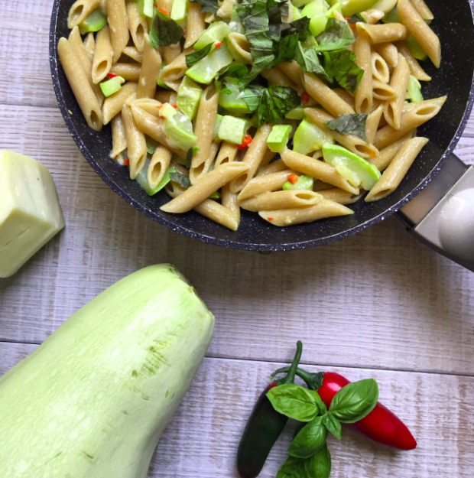

INGREDIENTS

- 320 gr Wholemeal Penne
- 2 Large Courgettes
- 1 Clove Of Garlic
- A Few Flakes Of Semi-Seasoned Sheep's Milk Cheese
- 1 Fresh Chilli
- 4 Soup Spoons Of Extra Virgin Olive Oil
- Some Basil Leaves
- A Pinch Of Integral Salt

PREPARATION

- Wash And Chop The Courgettes (About Penne Size). Wash The Fresh Chilli And Cut It In Half, Remove The Seeds From The Chilli, And Cut It Into Small Pieces.
- In a Pan, Heat The Oil With The Fresh Chilli And Garlic. In The Meantime Bring, The Water Poured Into a Large Pot To a Boil And Add The Coarse Salt. Boil The Pasta At The Same Time. And Courgettes.
- Before The Oil Fry, Turn Off The Heat And Set Aside.
- Chop The Fresh Basil Leaves, Prepare The Cheese Flakes.
- Drain The Pasta With The Courgettes And Pour Everything Into The Pan With The Oil, Garlic, And Chilli.
- Dish To Be Served Hot Or Lukewarm With Fresh Basil Confetti Dropped On Top.

NUTRITIONAL VALUE:

NUTRIENTS | PER SERVING | Daily Value %
Total Fat | 13g | 17%
Saturated Fat | 2.3g | 11%
Trans Fat | 1g
Total Carbs | 64g | 23%
Dietary Fiber | 9g | 32%
Total Sugars | 3g
Protein | 13g | 26%
Calories | 349

